First lady Jill Biden highlights Intel, community college training program in visit to Valley
Mar 8, 2022, 4:45 AM
Share
BY TAYLOR TASLER
KTAR.com
PHOENIX — First lady Jill Biden during a trip to Phoenix on Monday promoting President Joe Biden’s agenda took time to visit Intel’s campus in Chandler and highlight a training program the company is doing in partnership with Maricopa community colleges.
Maricopa Community College District’s accelerated program called Quick Start will prepare students for a career in the semiconductor industry as a technician by providing them with hands-on learning from Intel employees and instructors.
“It’s going to allow students to start up in a career in a growing sector that’s critical to our economy,” Biden said after touring Intel’s 700-acre Ocotillo campus, which produces microchips.
The program will consist of 10 four-hour classes over a two-week period.
Students who complete the program will receive industry-recognized certification, three hours of college credit toward an associate’s degree and a tuition stipend of $270.
There will also be an opportunity for graduates of the program to interview with Intel for a full-time position.
The Quick Start program is funded in part by the president’s American Rescue Plan.
RELATED STORIES

Intel breaks ground on $20 billion chip plants in Chandler
- 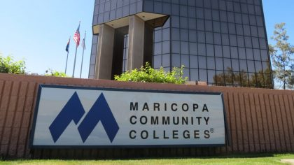

Maricopa Colleges select initial offerings for bachelor programs

AI program that started at Maricopa County colleges expanding nationwide
“Building a better America starts with you, and that’s why we’re going to keep investing in community college partnerships and workforce development,” the first lady said.
Enrollment for Quick Start is now open and will start in May at Mesa Community College, with the first class of the program consisting of all women.
As Intel makes a push to increase the number of women in technical roles from 20% to 40%, the first lady touted what the program means for women in the semiconductor industry.
“It means getting rid of the barriers that have kept women out of careers in engineering and manufacturing and other STEM fields,” she said.
The program will expand to Chandler-Gilbert and Estrella community colleges in the summer.
Last fall, Intel broke ground on a $20 billion investment in two new chip manufacturing factories at the Ocotillo Campus. Intel estimates the expansion will create 3,000 jobs with the company and 15,000 within the community.
Intel CEO, Pat Gelsinger, attended President Biden’s State of the Union address last week in the first lady’s viewing box. Biden recognized Gelsinger as he made a push for Congress to pass the Chips Act, which would provide chip makers $52 million to advance the semiconductor industry in the U.S.
“Investing in industries of the future, which we see here today, the kind of jobs that make our supply chain stronger, lowering prices and keeping our country safe,” the first lady said.
Biden after visiting Intel headed to a Democratic National Committee finance event. She will continue her three-day trip in Tucson on Tuesday before heading to Reno, Nevada, and Fort Campbell, Kentucky.

